AR systems as a cognitive learning support: teaching the solar system with UNIVERSUM

ERIC O. TORRES-VELASCO

Posgrado de Diseño y Visualización de la Información UAM-A

al2191801404@azc.uam.mx

ESTEFANÍA MEDINA-DUARTE

Posgrado de Diseño, Planificación y Conservación de Paisajes y Jardines UAM-A

al2201800564@azc.uam.mx

**Abstract**

In this work the implementation of an AR application is designed to function as a support in the teaching of topics related to the solar system and its various complements through more visual and interactive supports than those offered in traditional methods.

**Additional Keywords and Phrases:** ar systems, learning tools, solar system,

**1 INTRODUCTION**

Augmented Reality (AR) was born to traduce onto the real world digital materials in fictional layers made by digital devices such as smartphones which allows to feature the historical additional global data in types of text, numerical, audio, video or space experience.

This system could provide cognitive support for difficult tasks with a pedagogical affordance with rescaling the natural world in virtual objects as planetary bodies to students get better understanding. It means that an important function of AR is to «offer knowledge in a way that is more closely and immediately related to the world around us» (Bower, Howe, McCredie, Robinsons, Grover, 2014: 12).

In the field of education, AR systems can foster educational experiences because it triggers a powerful semantic of psychological associations through situated learning, that is, authentic learning contexts with activities and assessment guidance by an expert to legitimate peripheral participation. This performs the potential to radically transform the learning activity by making challenging concepts visible through AR (Dede, 2009; Radu, Schneider, 2019).

This is the reason why kids from eight to eleven years old should interact with this kind of emerging technology. Because at that age the children are developing new cognitive structures by motor sensing their spatials relations that influence their own way to understand the world around them.

Students could apprend difficult abstract concepts by designing a three-dimensional structure of the molecules for example or physical phenomenas to reduce significantly the cognitive load (Marshall, 2007; Radu; 2014; Radu, Schneider, 2019).

**2 This is where UNIVERSUM was born…**

**2.1 Activity Analysis**

The application will serve as support to traditional teaching methods, representing an addition of new techniques that include the use of mobile devices, like tablets or cell phones, which are already part of the technological objects commonly used by people, including children.

Beside, it will incorporate ludic and didactic tactics in order to attract most of the attention from kids, creating some sort of recreational and playful environment, making the learning process more fun and interactive.

Therefore, for its main characteristics the application can be described as a ludic AR atmosphere for kids among eight and eleven years old. These characteristics were chosen based on what was said for different authors over the years. In first instance, is is set that from childhood to maturity, play has a central place at each stage of development in its different forms, styles and meanings (Erikson, 1950; Piaget, 1962; Vygotsky, 1978; Wolf, 1984), and in Mainemelis et al (2010), is established that:

...play exemplifies one of the highest forms of experiential learning in three fundamental ways: first, it encourages learners to take charge of their own learning based on their own standards of excellence. In play, learners achieve authentic and higher order learning by creating their own game rules and conduct. Second, an equal value is placed on the process and the outcome of learning. Play does not happen staring at the scoring board. Outcome acquires meaning only if equal attention is paid to the experience and the process of play. As Dewey (1997, p. 167) says, a truly educative experience sees no difference between utility and fun, the process and outcome. Third, in play, the experiential learning cycle is fully engaged by allowing players to come back to the familiar experience with a fresh perspective. The recursive nature of the play activity gives continuity for the individual’s experience to mature and deepen, moment-to-moment, and stage-by-stage. Taken together, these three factors are the key principles of a learning space conducive to deep learning.

In addition, James and Swain (cited in Johnson-Glenberg, 2017: 196) point out that «when 5- to 6-year-old children actively manipulated an object while hearing a new label and then heard the label again, motor areas of their brains were more likely to be activated upon subsequent viewing compared with when they were only allowed to passively watch an experimenter manipulate the named object» (James & Swain, 2011).

### 2.1.1 Key design decisions

The main decisions were taken in face of making an AR application for kids, since in many of the course’s readings it was mentioned that engagement and immersion highly increases when these technologies are implemented (Dunlevy, 2009; Radu, 2014).

**2.1.2 Opportunities for data collection**

Interviews with both type of users: teachers and students

### 

### 2.1.3 Ways to assess learning outcomes

Beside the visualization of the components of the solar system, the application can include some after questionnaires whose results can be sended to the teachers.

Aside, the functionality of the application can be evaluated through more traditional methods like tests or reports.

### 

### 2.1.4 Ways to evaluate the design

The results of the questionnaires included after the visualization of the components can be also saved in a server to evaluate which aspects are left behind for the users, apart from it, the feedback from the interviews with teachers and students can also work to see deficiencies on the application.

## 

## 2.2 Alpha version of the software

For the Alpha version, was taken into account the flashcards design by the objectives of the project. First, it was applied for the highest rate about the visual pattern with the target uploaded at Vuforia.

### Fig. 1 Flashcards version 0.1

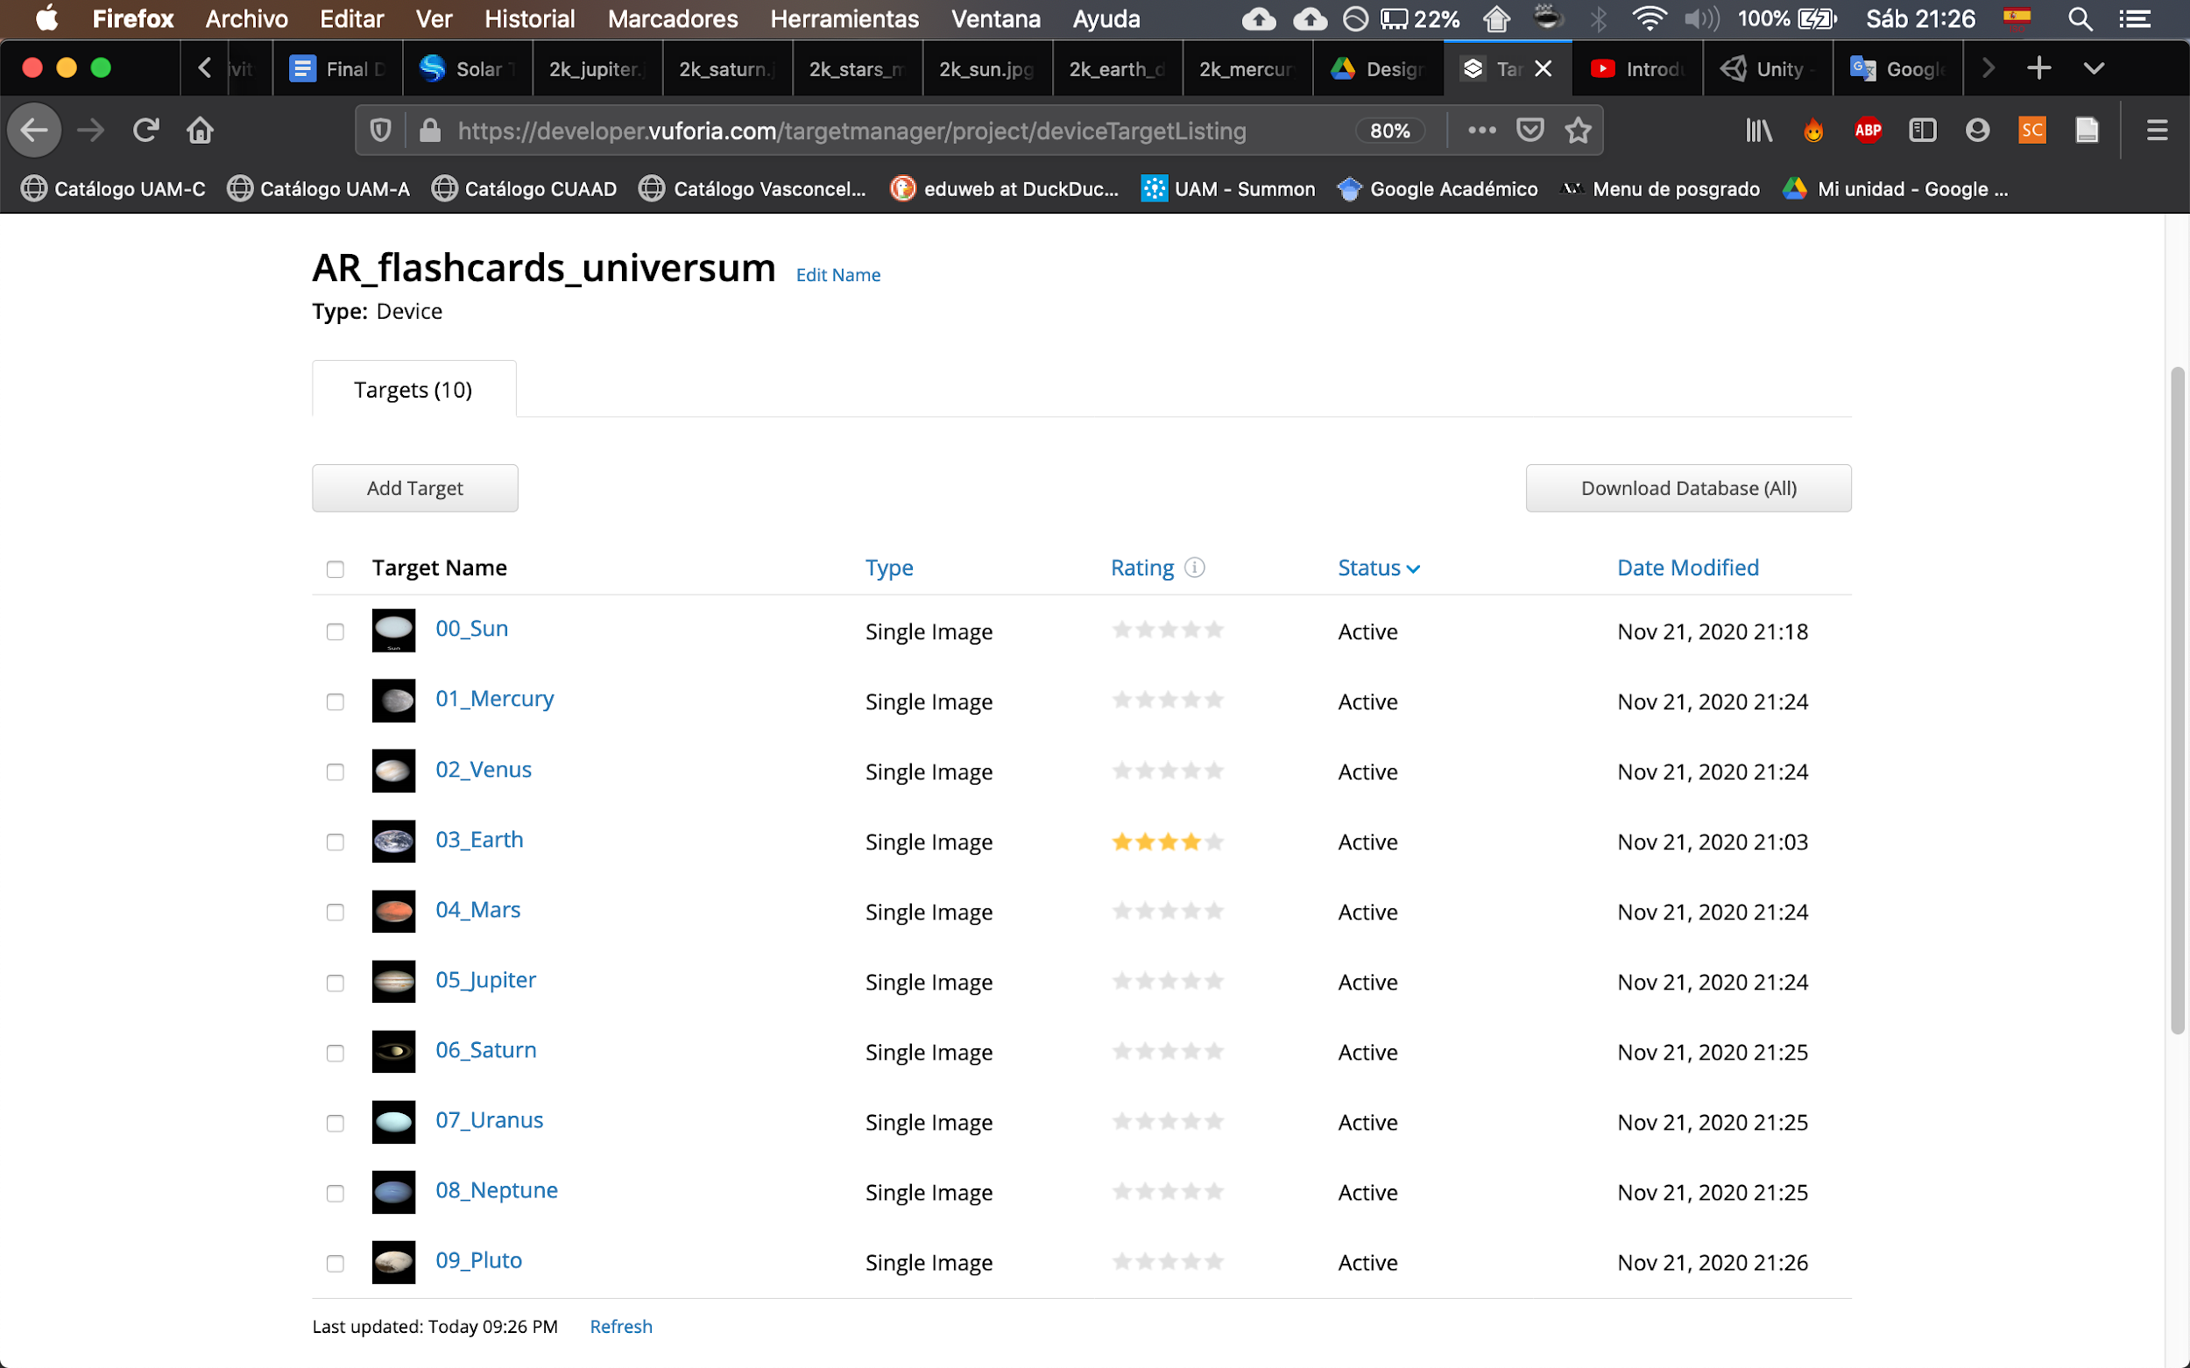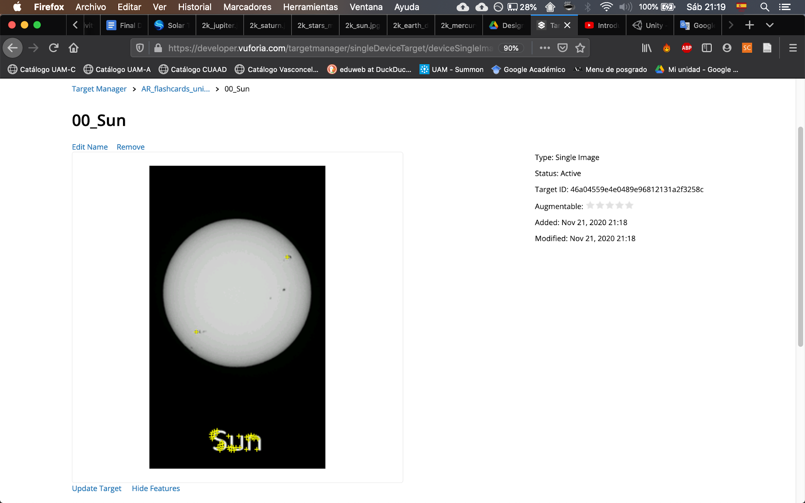

### 

### Source: own elaboration

### Fig. 2 Flashcards version 1.0

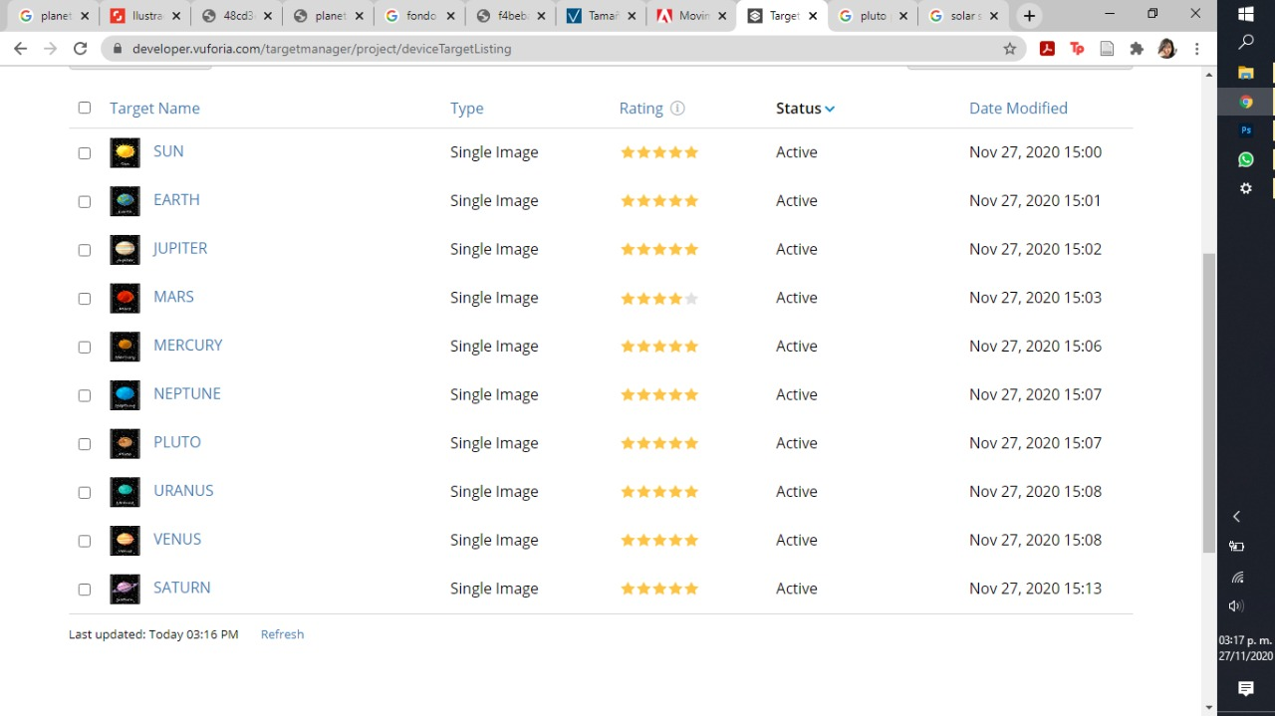

Source: own elaboration

Then, a Unity-AR project to model the behaviors from the different elements of a solar system like ours was created. This is considering nine planets and the Sun, obtaining their textures for the material from web site Solar System Scope (<https://www.solarsystemscope.com/textures/>).

### Fig. 3 Textures

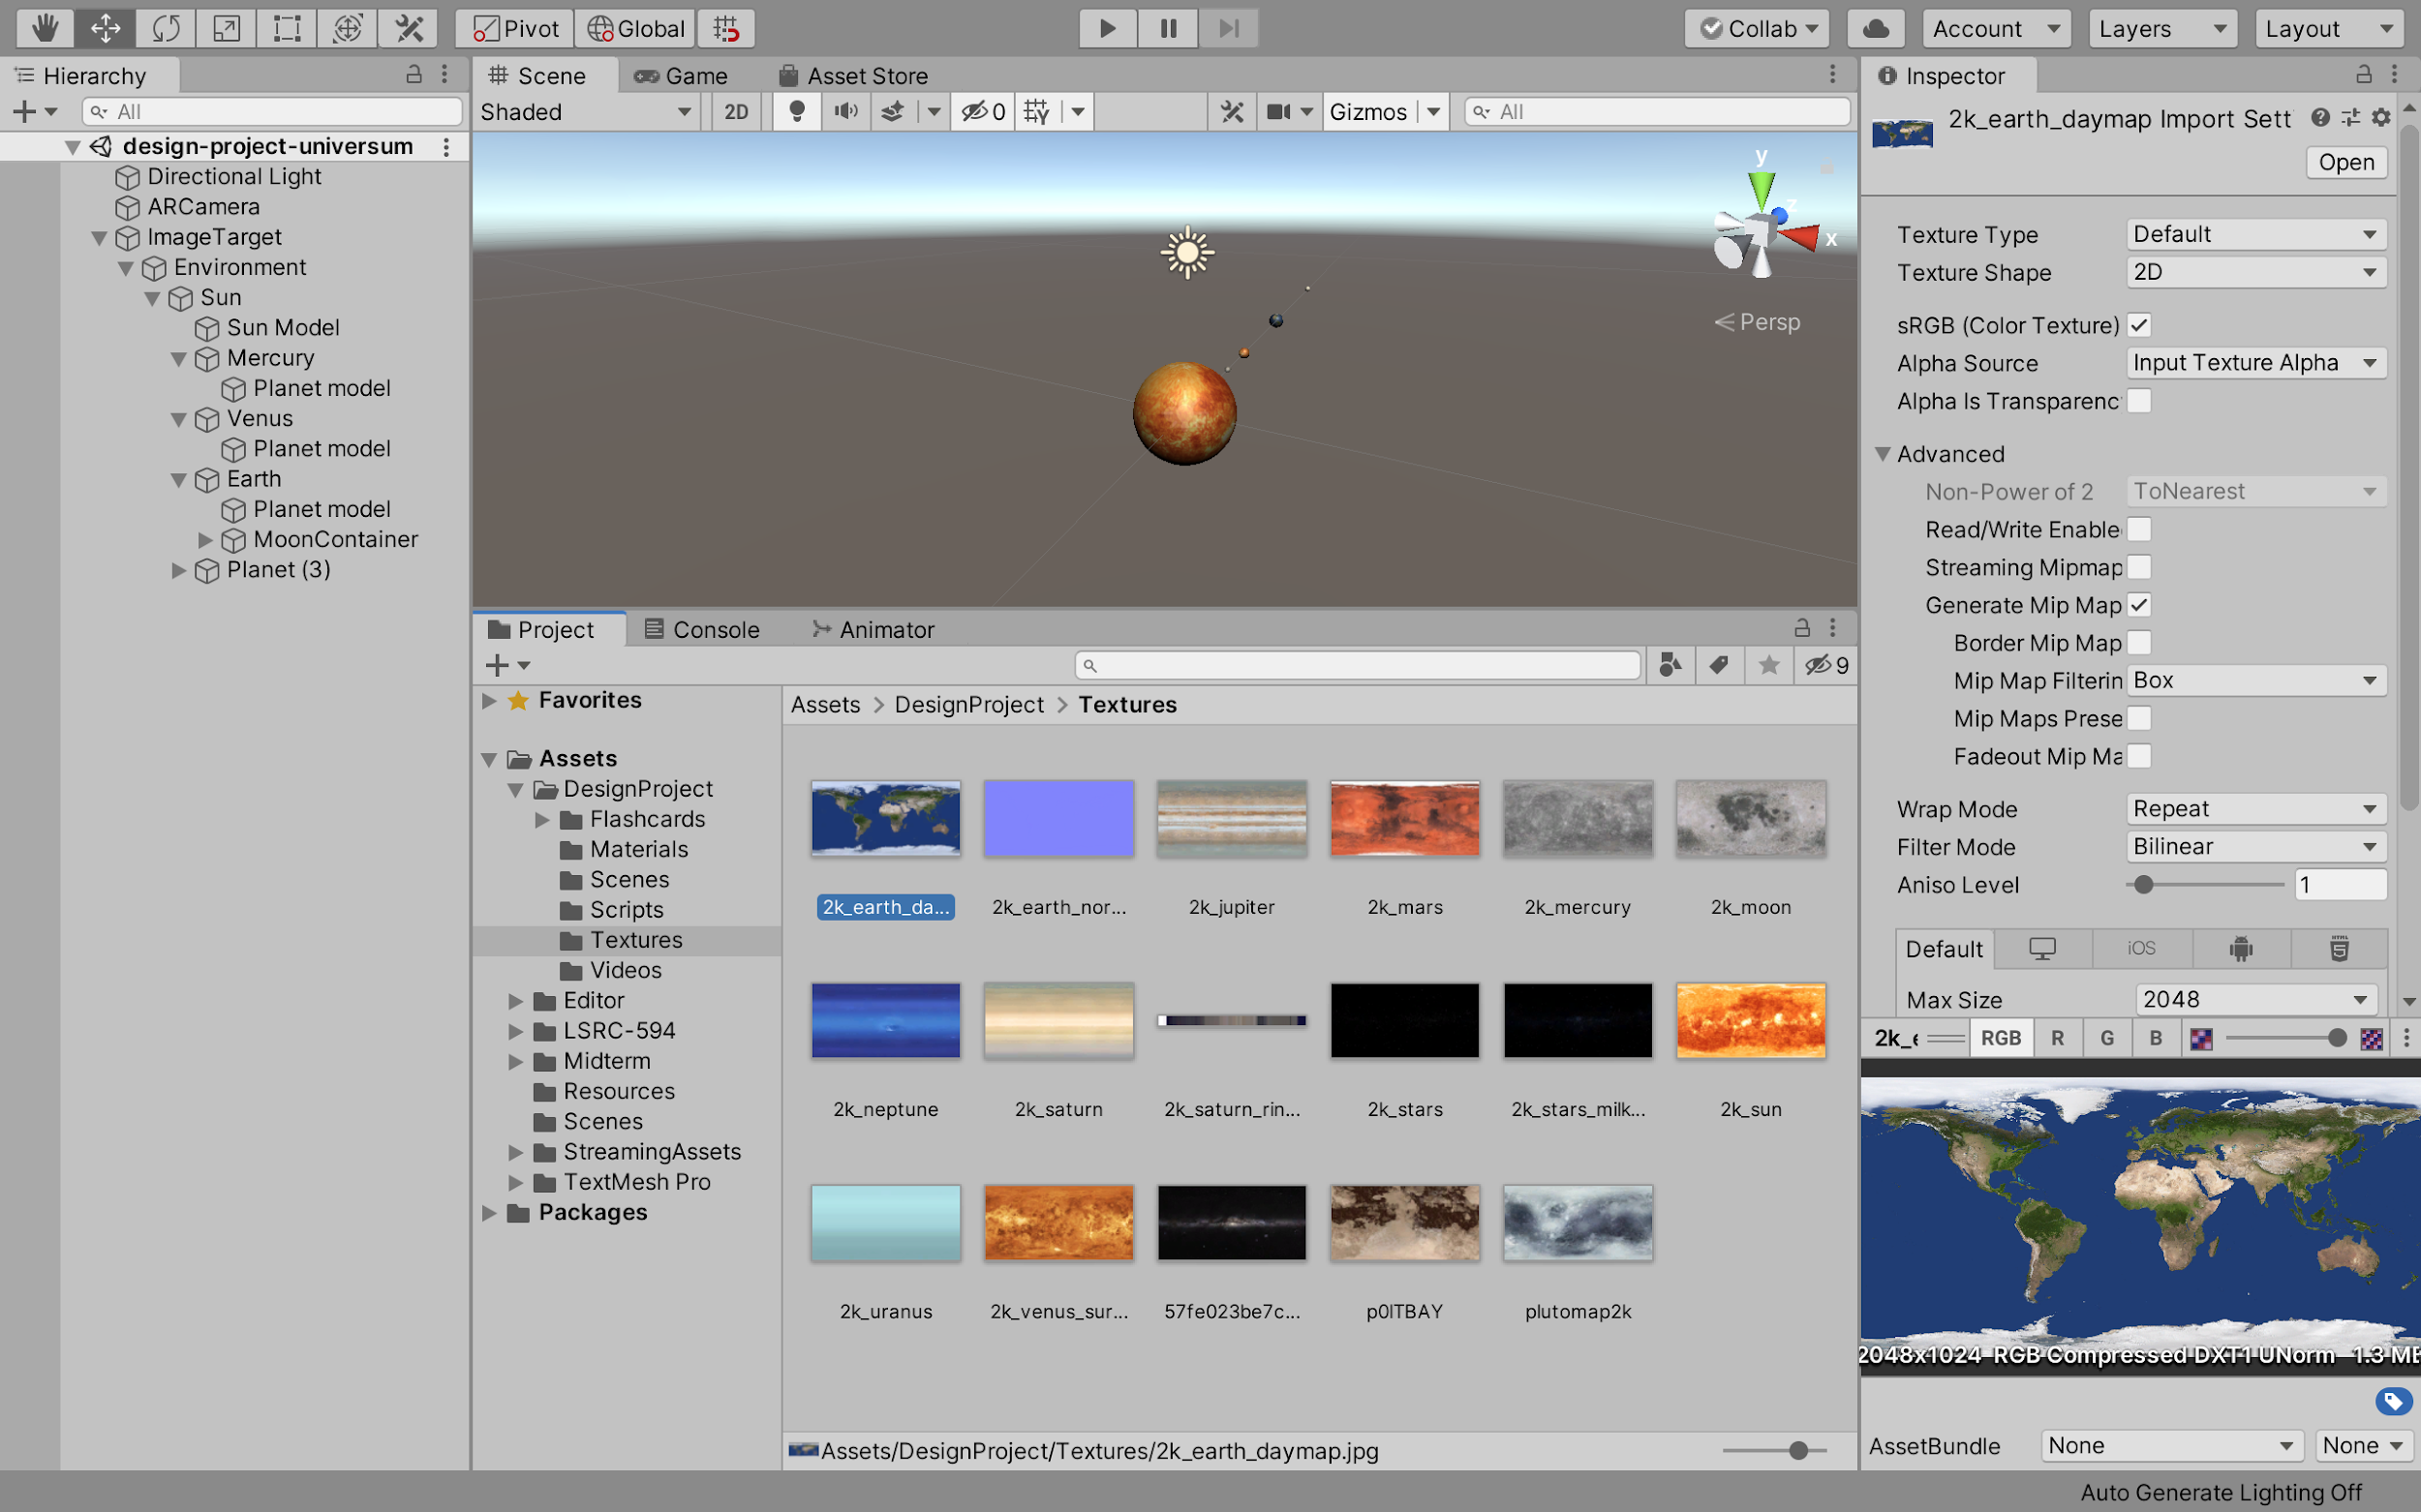

### Source: own elaboration

### Fig. 4 Materials

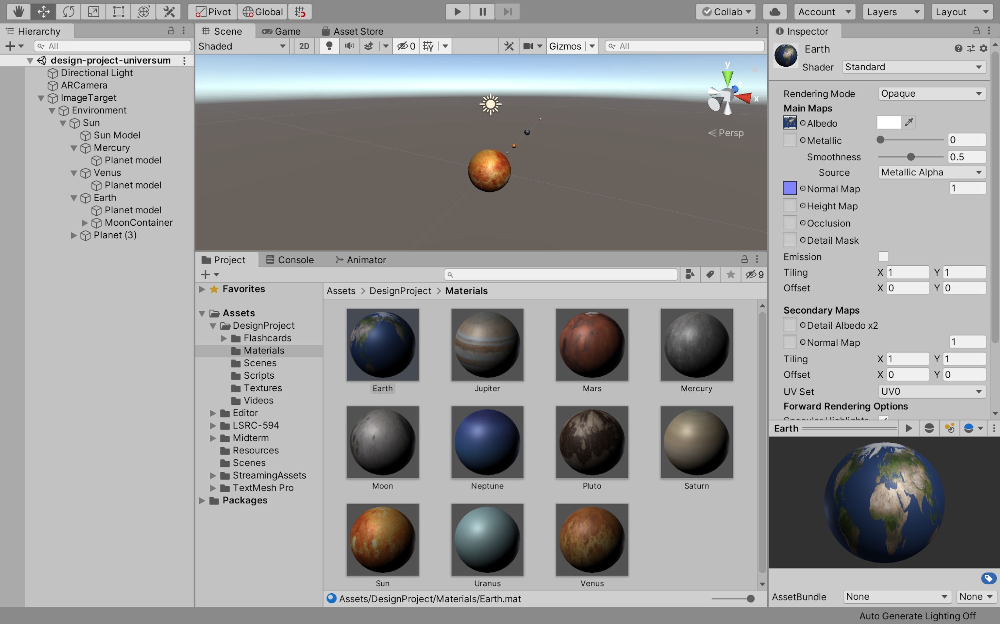

### Source: own elaboration

So, the orbit behavior motion was developed by nesting the planet model on an empty Game Object referencing the planet Transform, an orbit period depending on the model, a X and Y axis, and a progress orbit.

### Fig. 5 Orbit Behavior Script

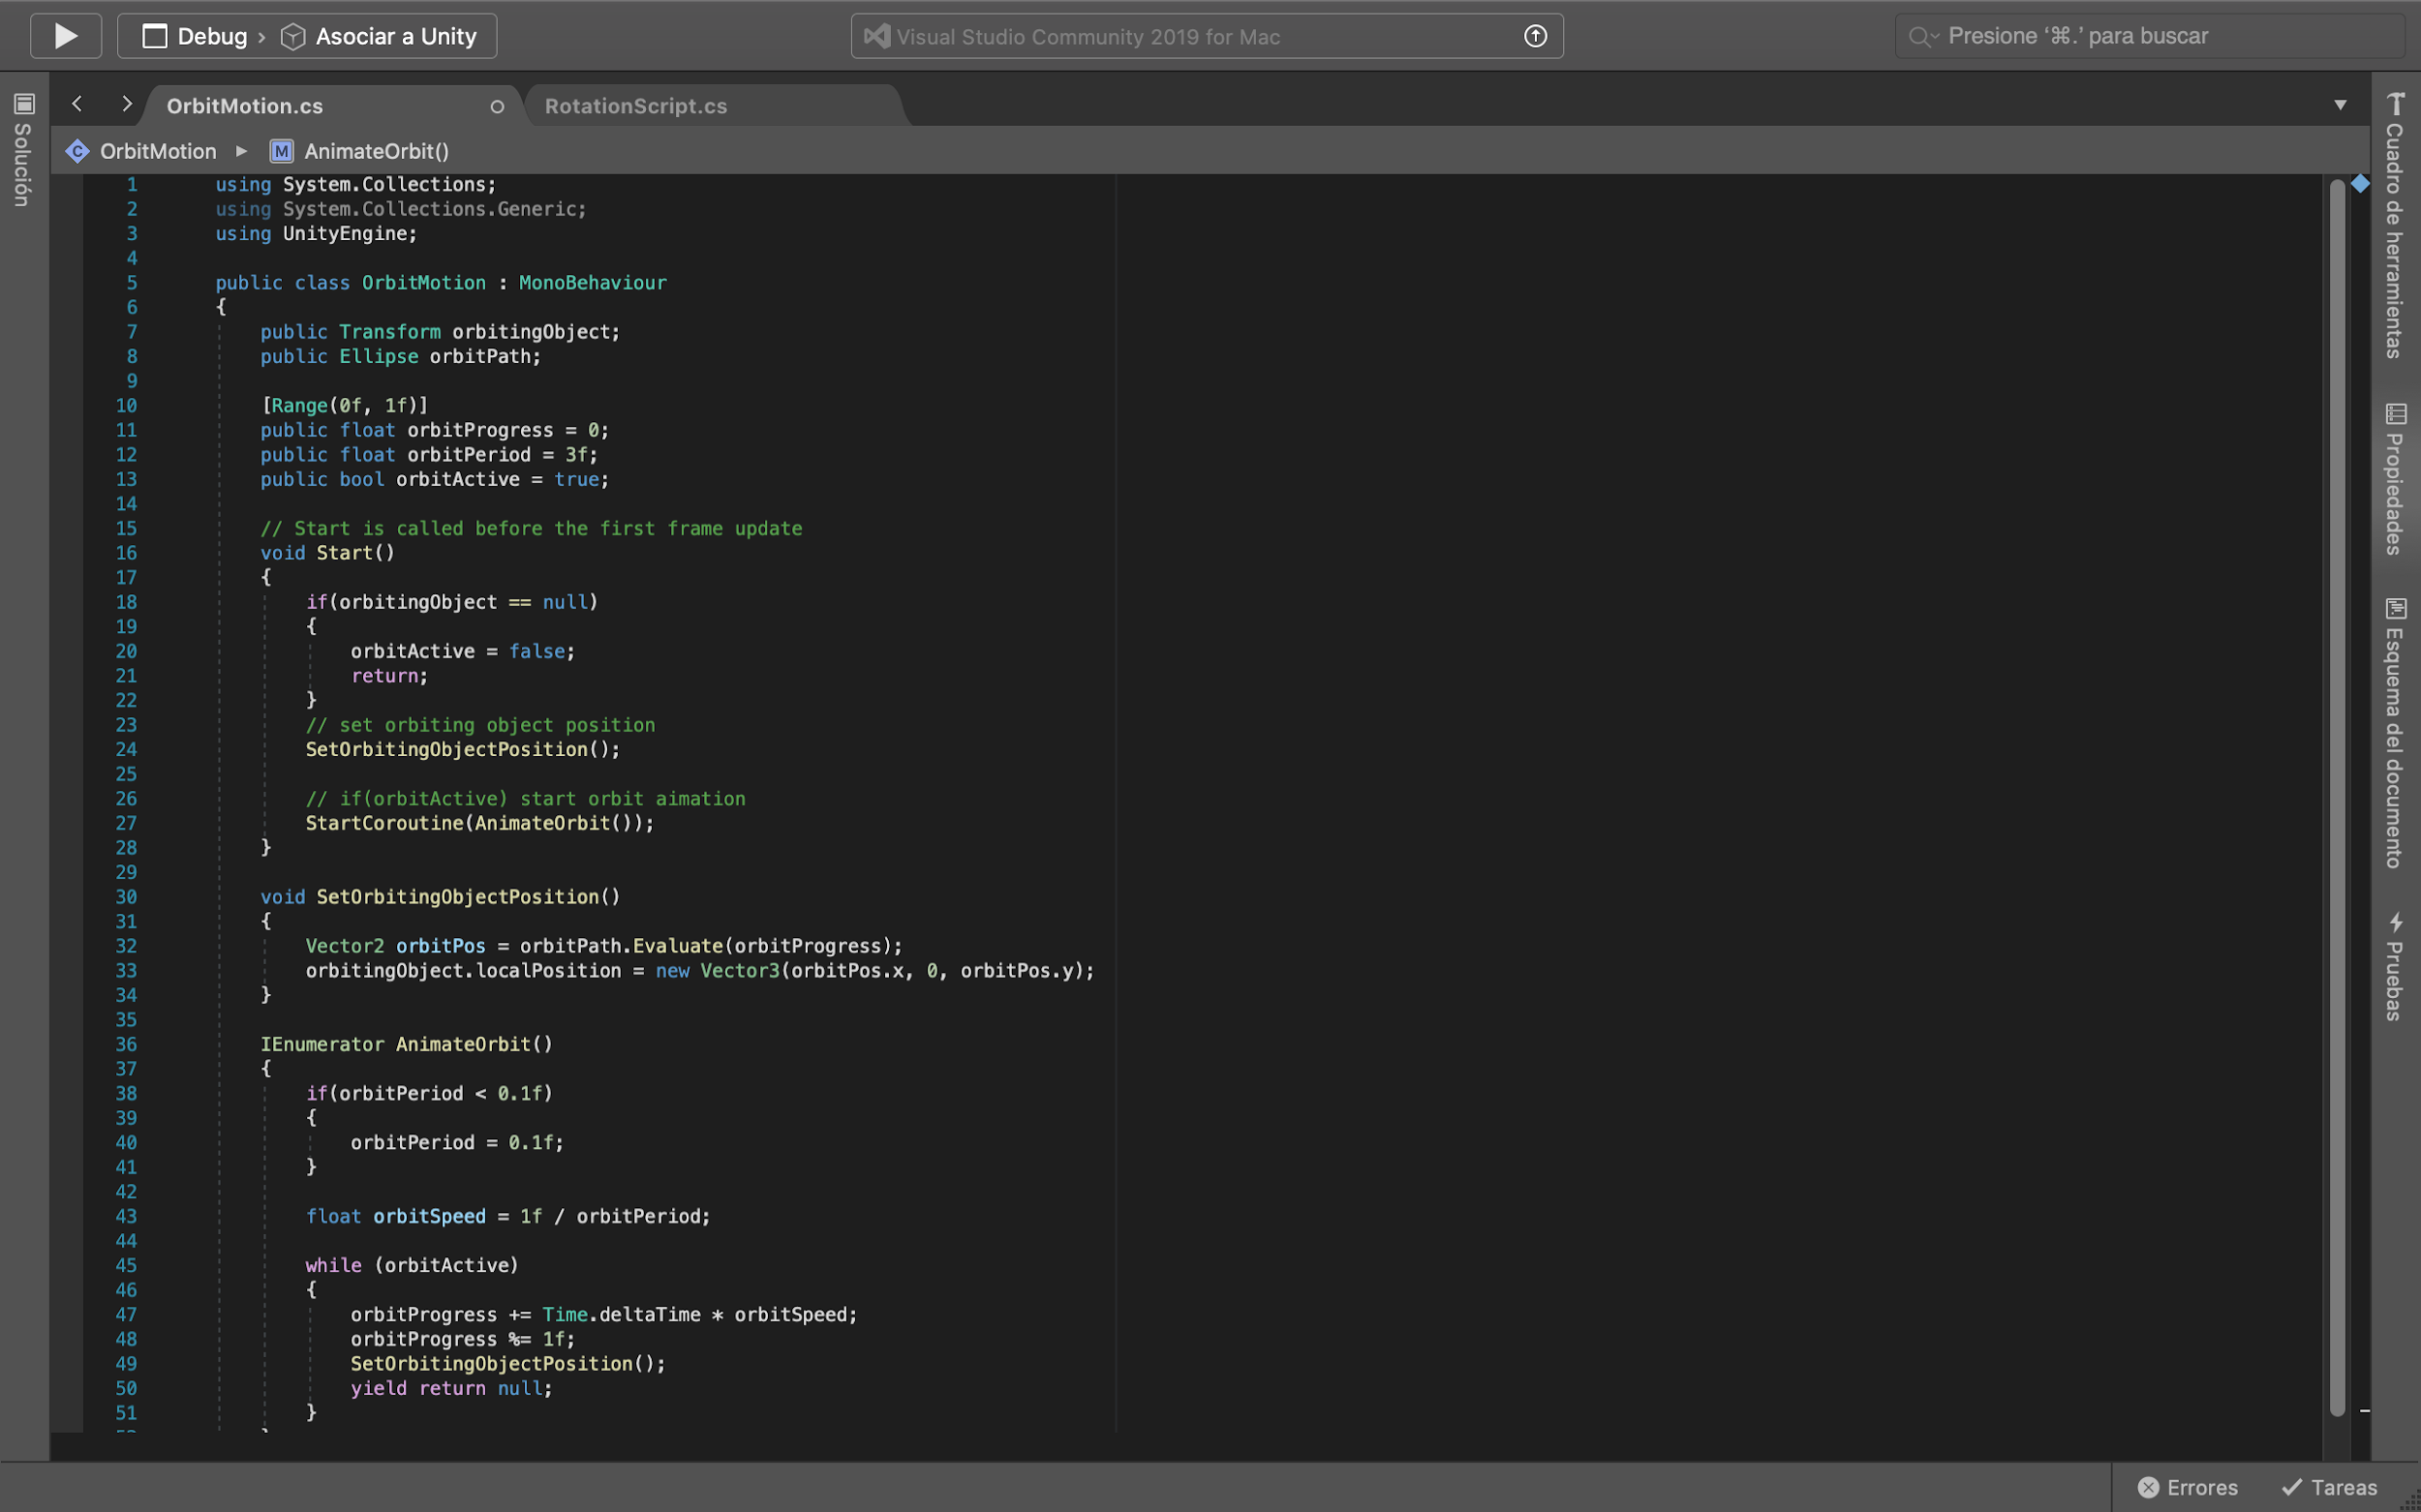

### Source: own elaboration

### Fig. 6 Rotation Behavior Script

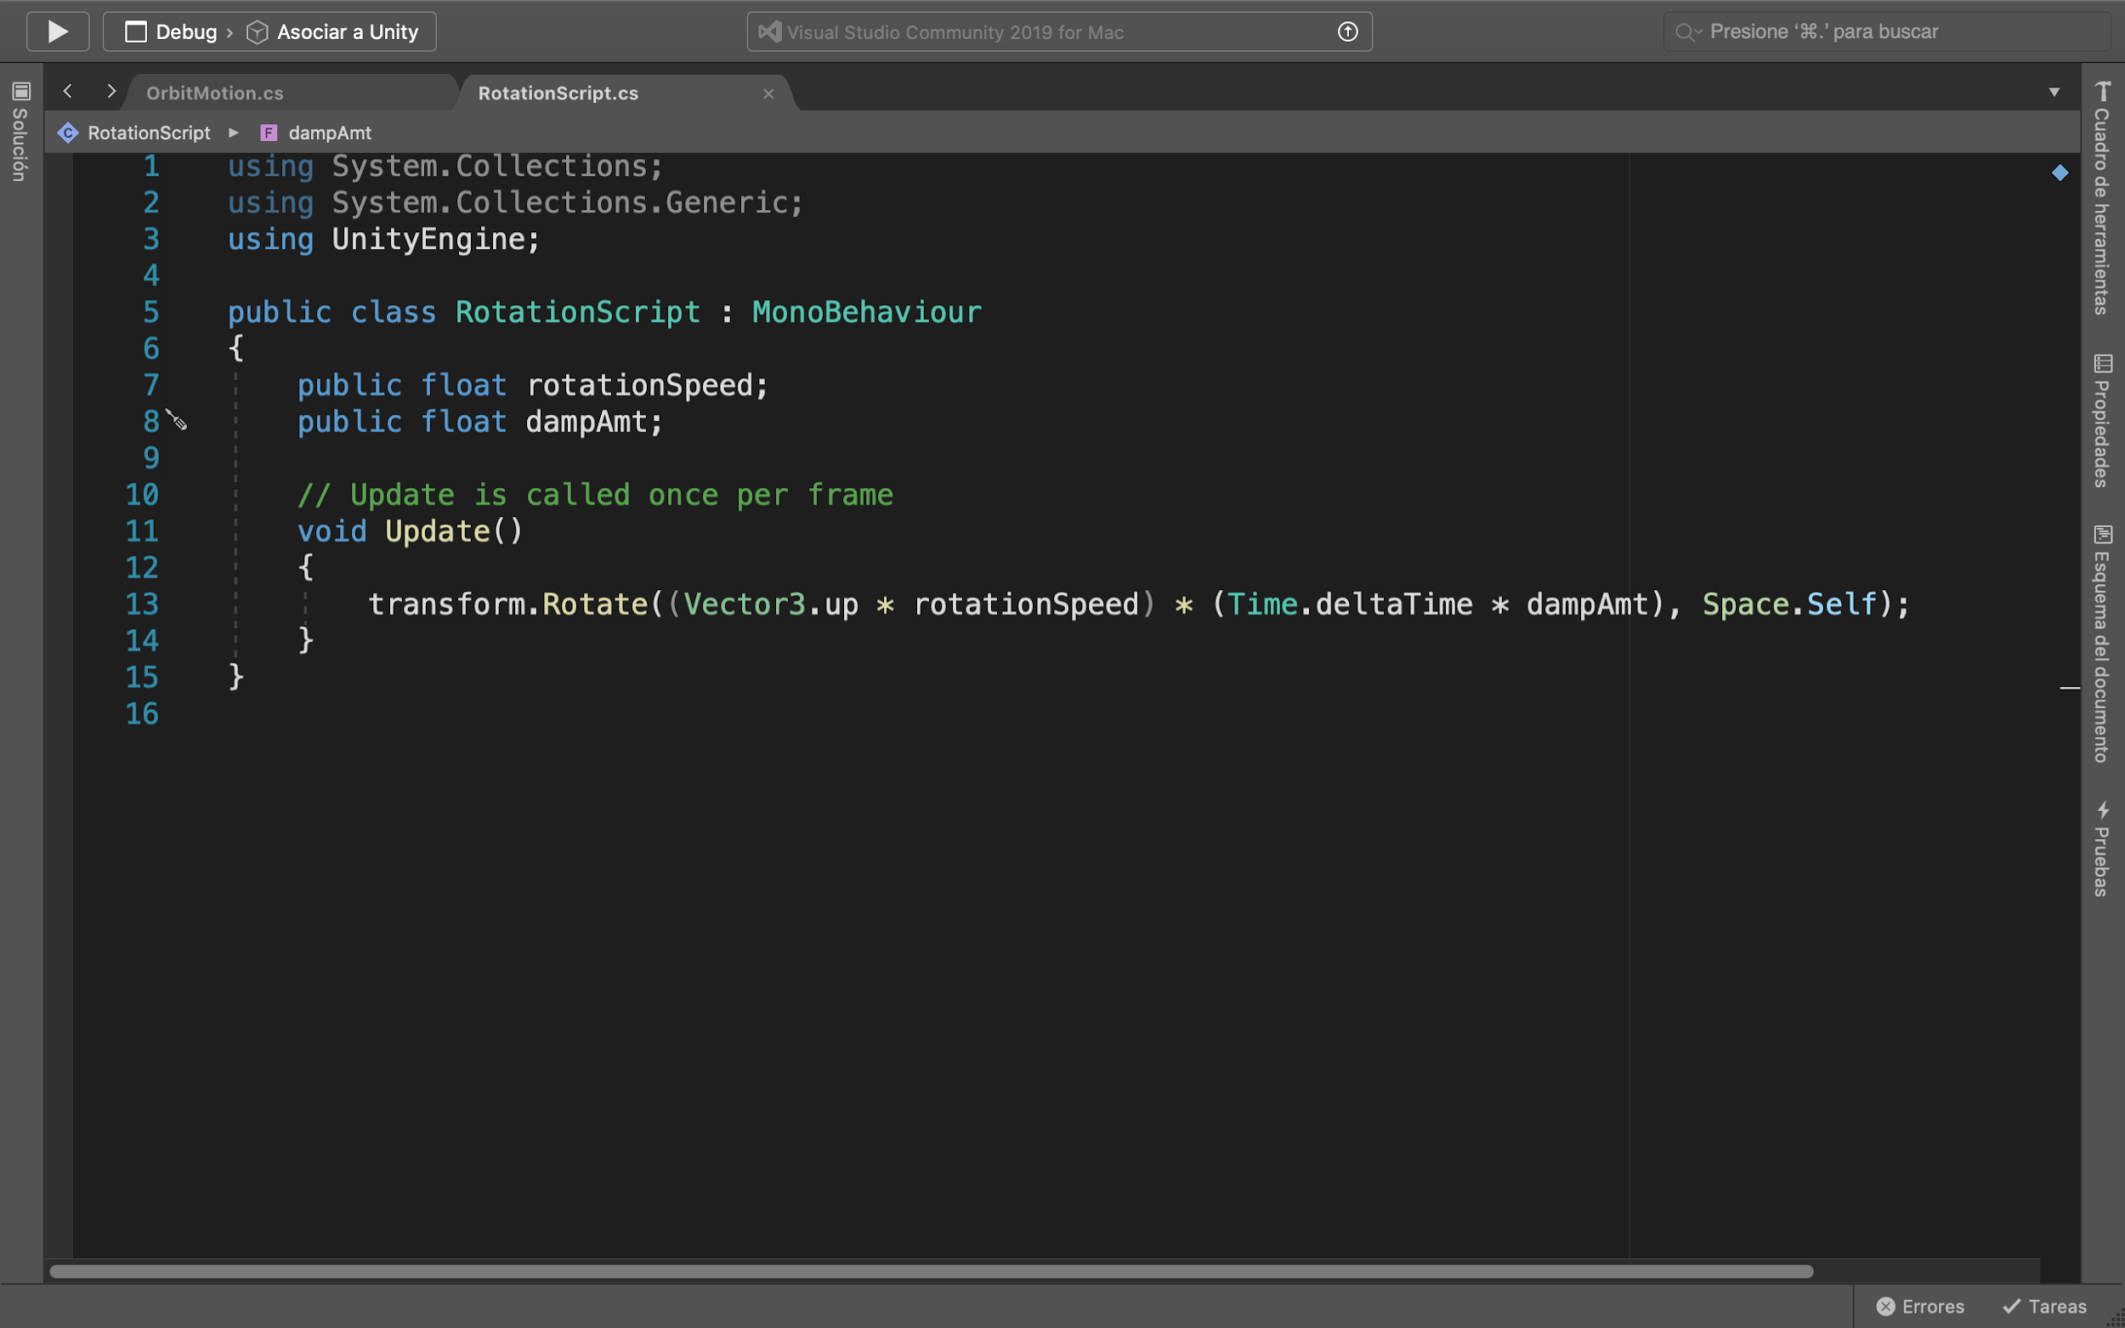

### Source: own elaboration

So, internally the planet model poses a rotation movement behavior that depends from the speed rotation and the Damp Amt.

### 

### Fig. 7 Prototype

### 

### Source: own elaboration

So, it is observed how the AR System UNIVERSUM tries to imitate the natural aspect of the components of a solar system. This means that it presents a simulation of the similarity of a solar system like the one we live, occupy or space. The humans embodied the spatial concept of a phenomenon to a true possible nearest knowledge mapping.

**3 CONCLUSIONS**

It is clear that AR applications support cognitive learning as a supplemental for the traditional learning methods. Otherwise, it is important to interact with multiple representations that complement the same phenomenon with different perspectives and strategies as with the tangible interface or embodiment the learning space with the constructing models that at least we know about how the virtual and real world are.

Tacit knowledge is difficult to obtain in these covid days, but there is a motivation to engage with content and encourage collaboration to democratize information access. This artificial environment could be reproduced creating metaphorical representations of order to bring people knowledge that we normally could reach by direct experience.

Currently, the first prototype has been developed, which can be seen in the following Online Resource 1 (https://sites.google.com/view/ar-universum/inicio); where a video with the basic interaction of UNIVERSUM is shown.

**ACKNOWLEDGMENTS**

This work is part of “Designing Technologies for Learning: Interaction and Embodiment is Space and Time” course offered by the University of Illinois at Chicago’s (UIC’s) [Learning Science Research Institute](https://lsri.uic.edu/) (LSRI) and Universidad Autónoma Metropolitana-Azcapotzalco (UAM-A’s) [Programa de Posgrado en Diseño](http://cyadposgrados.azc.uam.mx/) during fall 2020 coordinated by Marco Vinicio Ferruzca Navarro (UAM-A) jointly with Brenda López Silva (UIC).

**REFERENCES**

Bower, M., Howe, C., McCredie, N., Robinsons, A., Grover, D. (2014). Augmented Reality in education: cases, places and potentials. ​*Educational Media International,* ​vol. 51, pp. 1-15. doi: <https://doi.org/10.1080/09523987.2014.889400>

Cuendet, S., Bonnard, Q., Do-Lenh, S., Dillenbourg, P. (2013). Designing augmented reality for the classroom. ​*Computer & Education,* ​vol. 68, 557-569. doi: <https://doi.org/10.1016/j.compedu.2013.02.015>

Dede, C. (2009). Immersive interfaces for engagement and learning. ​*Science,* ​vol. 323, issue 5910, pp. 66-69. <https://doi.org/10.1126/science.1167311>

Donald, E. Knuth. 1997. The Art of Computer Programming, Vol. 1: Fundamental Algorithms (3rd. ed.). Addison Wesley Longman Publishing Co., Inc.

Dunleavy, M., Dede, C., Mitchell, R. (2009). Affordances and Limitations of Immersive Participatory Augmented Reality Simulations for Teaching and Learning. ​*Journal of Science, Education and Technology,* v​ ol. 18, no. 1, pp. 7-22. doi: <https://doi.org/10.1007/s10956-008-9119-1>

Horn, Michael S. (2018). Tangible Interaction and Cultural Forms: Supporting Learning in Informal Environments. *Journal of the Learning Sciences*, 27:4, 632-665, DOI: 10.1080/10508406.2018.1468259

Johnson-Glenberg, M. C. (2017). Embodied education in mixed and mediated realities: some results and principles for VR content design. In

Lui, M., McEwen, R., Mullally, M. (2020). Immersive virtual reality for supporting complex scientific knowledge: augmenting our understanding with physiological monitoring. British Journal of Educational Technology. doi: ​<https://doi.org/10.1111/bjet.13022>

Mainemelis, C., Altman, Y., Kolb, A. Y., & Kolb, D. A. (2010). Learning to play, playing to learn. Journal of Organizational Change Management.

Marshall, Paul. (2007). Do tangible interfaces enhance learning? ​*Proceedings of the 1st interna- tional conference on Tangible and embedded interaction*,​ 15-17 February 2007, Baton Rouge, Louisiana, USA.

Noble, J. (2009). Programming Interactivity: A Designer’s Guide to Processing, Arduino, and openFrameworks. USA: O’Reilly Media, Inc.

Radu, I. (2014). Augmented reality in education: a meta-review and cross-media analysis. Personal Ubiquitous Computing, vol. 18, pp. 1533-1543. doi: https://doi.org/10.1007/s00779-013-0747-y

Richards J. (2017). Infrastructures for Immersive Media in the Classroom. In Liu D., Dede C., Huang R., Richards J. (eds), ​*Virtual, Augmented, and Mixed Realities in Education* ​(pp. 89-104). Smart Computing and Intelligence. Springer, Singapore. <https://doi.org/10.1007/978-981-10-5490-7_6>

Sten Andler. 1979. Predicate path expressions. In Proceedings of the 6th. ACM SIGACT-SIGPLAN Symposium on Principles of Programming Languages (POPL '79), January 29 - 31, 1979, San Antonio, Texas. ACM Inc., New York, NY, 226-236.<https://doi.org/10.1145/567752.567774>

Winn, W. (2002). Learning in artificial environments: embodiment, embeddedness and dynamic adaption.